Class Assignment 2

컴퓨터소프트웨어학부 2017030482 허은진

1. How to run the program

: I use a single file to implement the program.



1. The requirements I implemented and some screenshot images

A. I used ClassAssignment1 code for the camera and drew the reference grid plane.

B. 1. I open the obj file by drag-and-drop to window using glfwSetDropCallback. Also, it renders only one obj file at a time.

2. I draw the polygon by reading the obj file.

3. The polygon is toggled to wireframe mode when pressing Z key, and it toggled to solid mode when pressing Z key again.

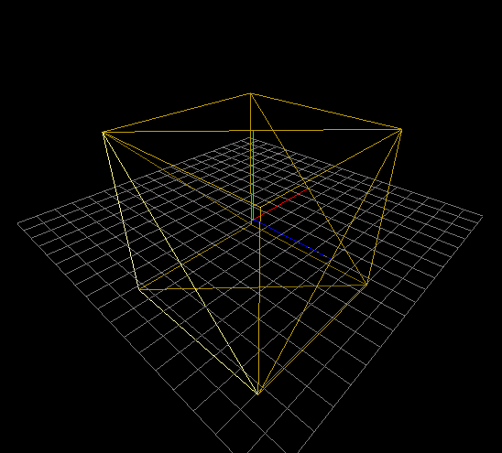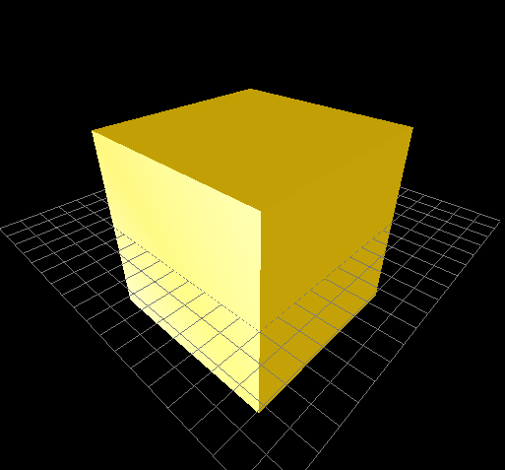

4. I print all the information of the obj file which include its file name, total number of faces, number of faces with 3 vertices, number of faces with 4 vertices, and number of faces with more than 4 vertices.

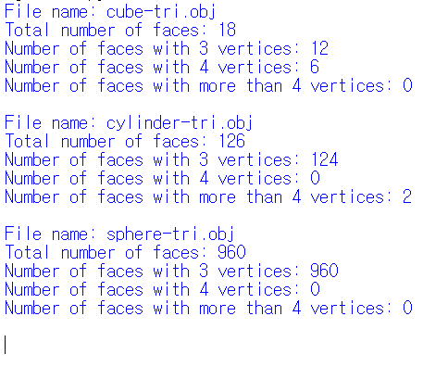

C. Lighting

: I used two light sources (One is directional and another one is point light). The color of both lights is white (1,1,1). The material color is (0.95,0.78,0.).

D. Extra credits

1. I use glDrawArrays() to render a triangle mesh and use glDrawElements() to render a triangle when pressing S key.

2. The polygon is toggled to forced smooth shading when pressing S key, and it is toggled back to flat shading mode when pressing S key again. I calculated new vertex normal vectors.

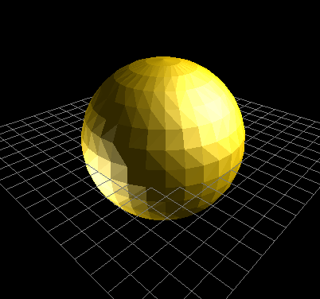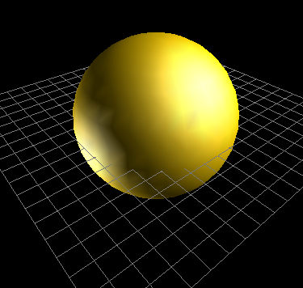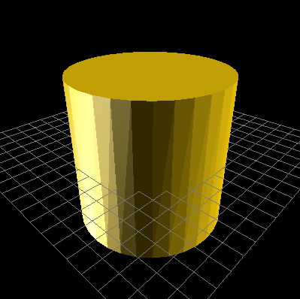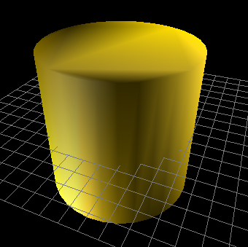

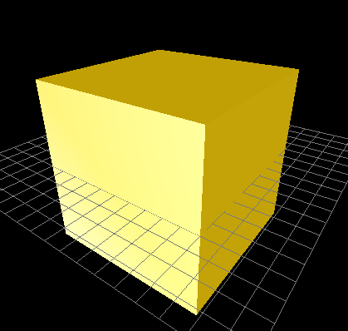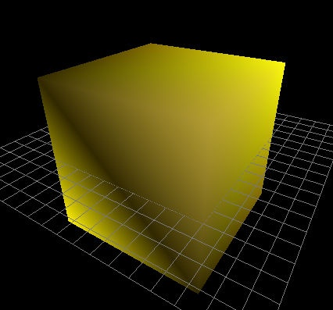

1. Some screenshot images of obj files downloaded in give websites

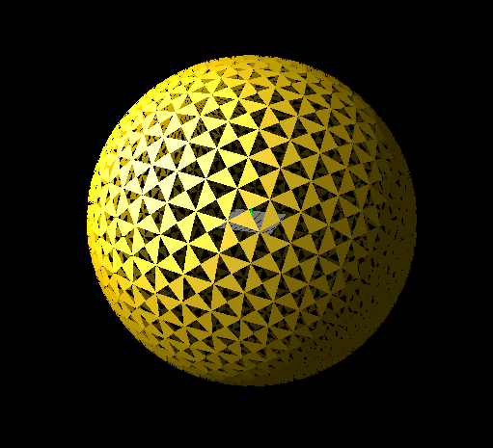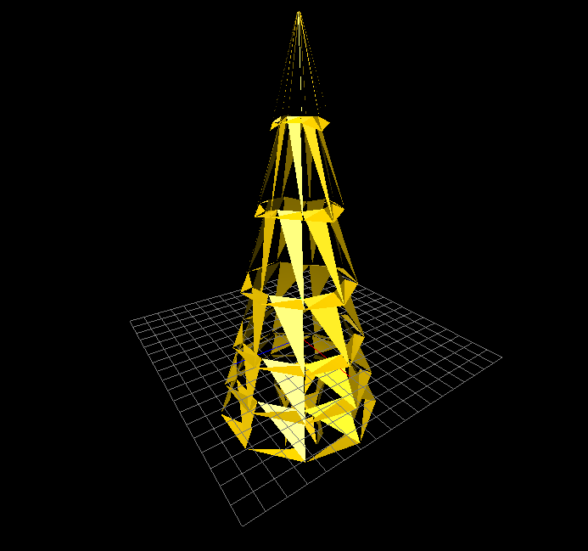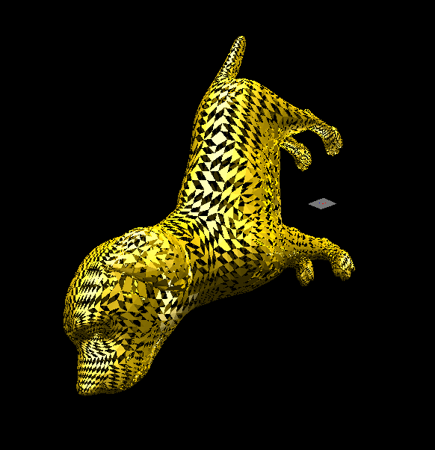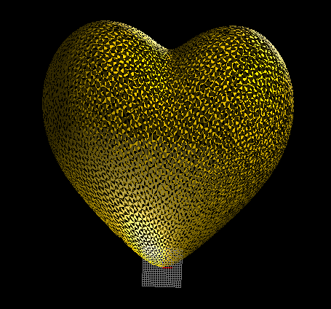

1. Lighting Configuration

1. How many light sources? I use 2 light sources

2. Where do you put the light sources? The light locations are (3,3,3) and (-3,-3,-3).

3. What is the type of each light source (point light or directional light)? The light of (3,3,3, 0) is directional, and the light of (-3,-3,-3,1) is point light.